**What I Used It For**:

I used **Chat GPT** to automatically generate insights from a CSV file that contained sales data. After uploading the dataset into Tableau, I asked Tableau GPT to explain trends in monthly sales and identify top-performing products. It quickly generated clear explanations and suggested charts to visualize the data, such as line charts for trends and bar charts for top categories.

**ScreenShorts**: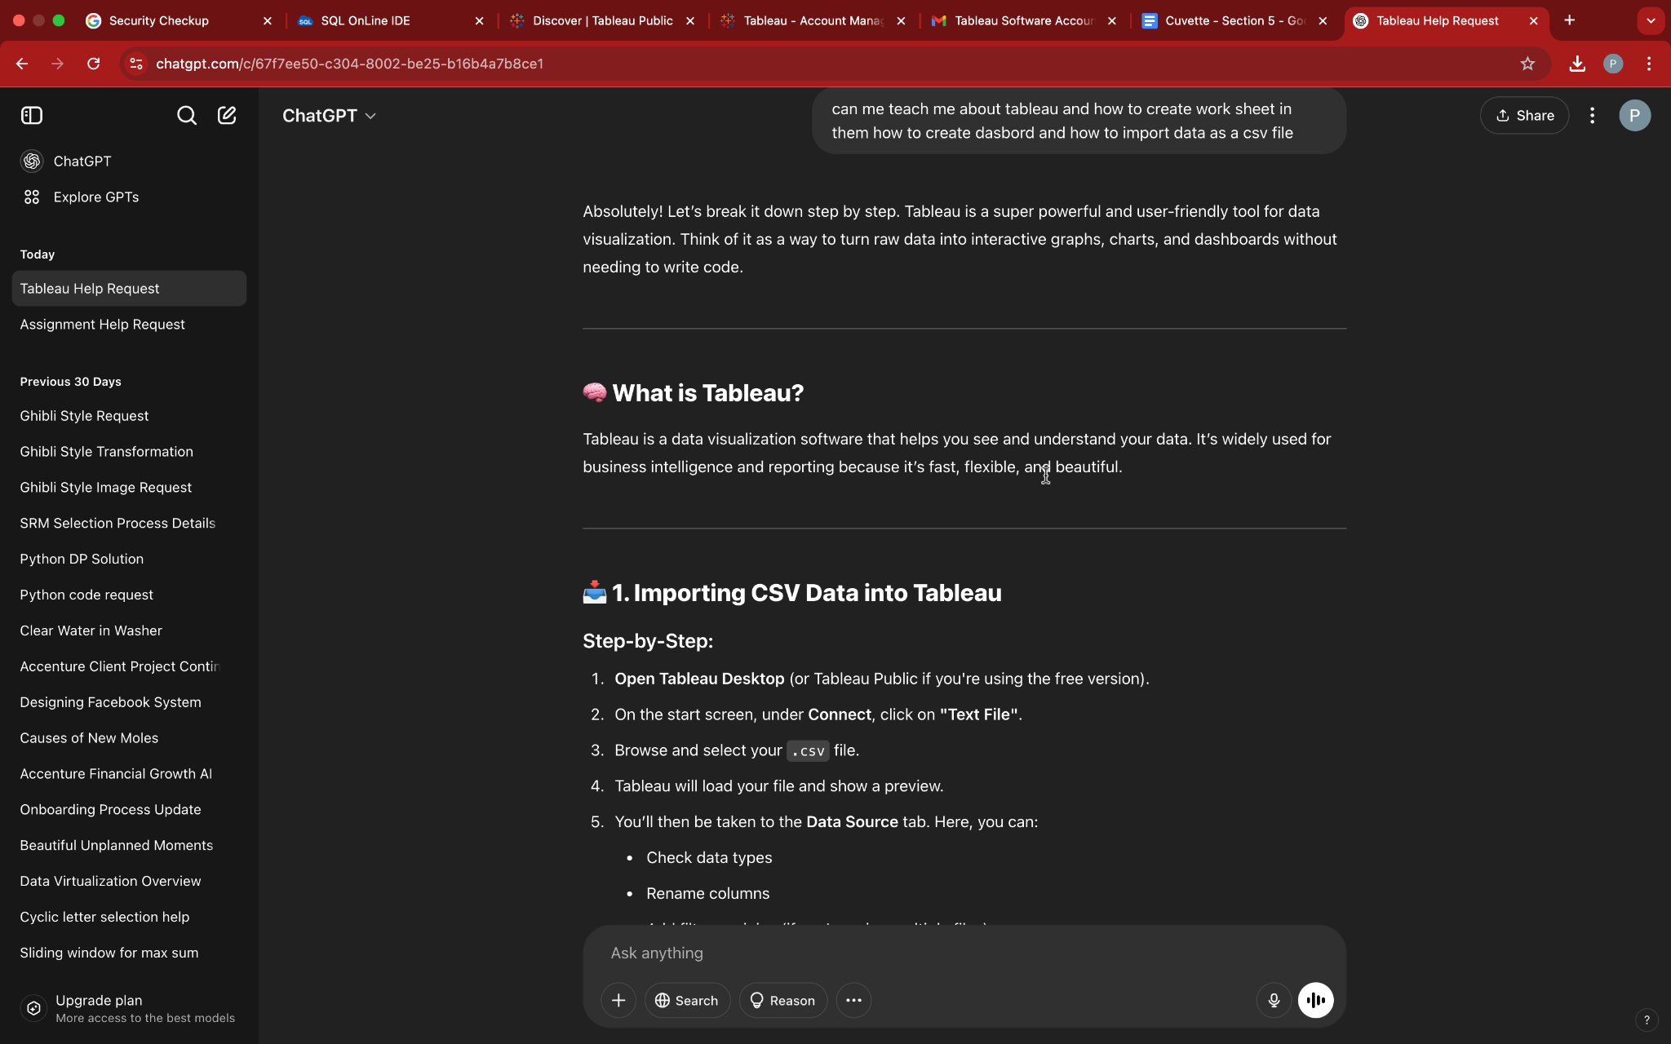

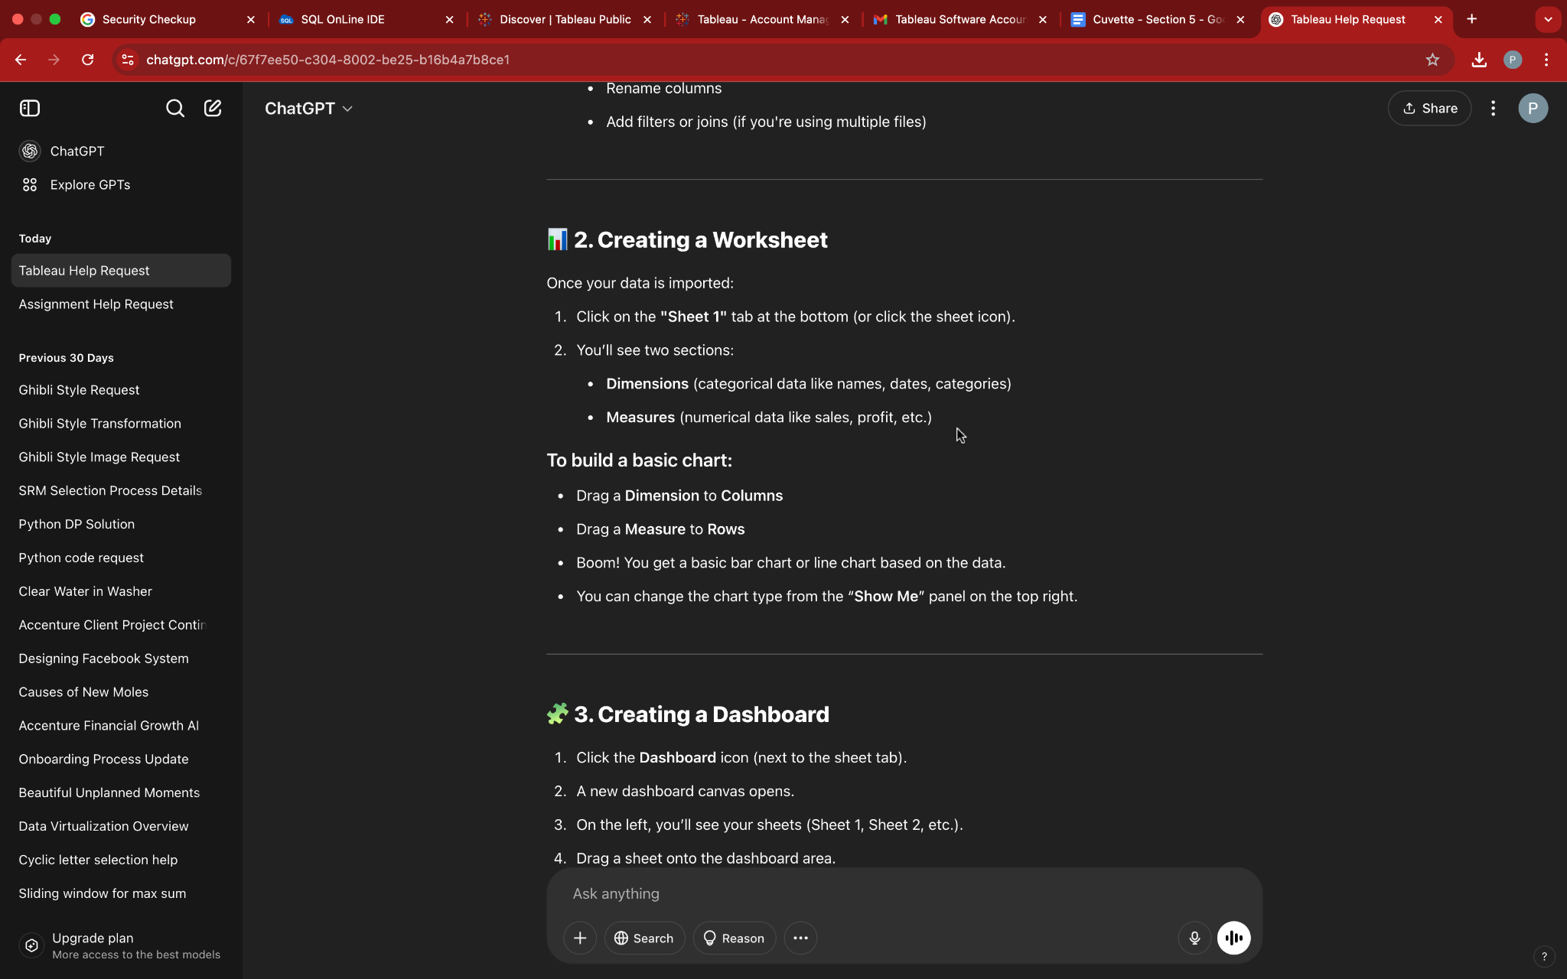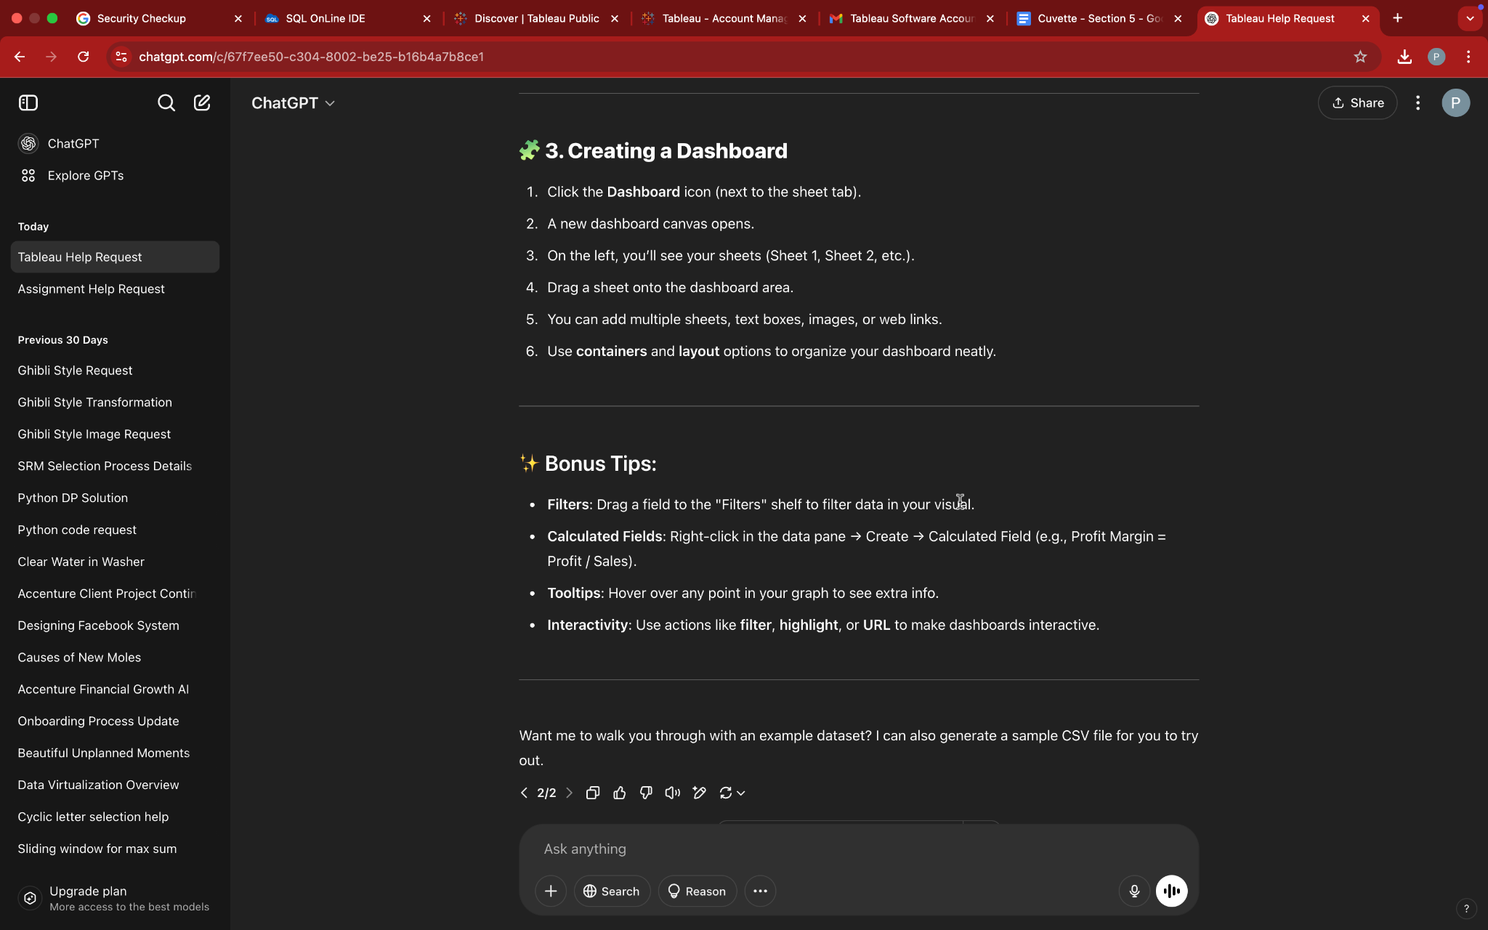

### **How This Tool Could Help Students in the Course:**

Chat GPT can significantly help students by:

* **Saving time** analyzing data — it automatically finds patterns and trends.
* **Reducing the learning curve** — students don’t need deep knowledge of Tableau to start using it effectively.
* **Improving data storytelling** — it provides natural-language explanations, which help in writing reports and presentations.
* **Boosting confidence** in data interpretation, especially for beginners who are unsure how to visualize or explain data properly.

This makes Chat a powerful assistant for any data analysis or business intelligence coursework.